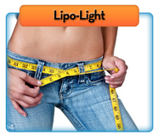

Lipo-Light

Our Lipo-Light utilizes LED light technology for spot fat reduction, inch loss and body contouring in almost any area of the body.
The Lipo-Light is 100% noninvasive, with no known side effects.
The Lipo-Light was designed to specifically target subcutaneous fat, reducing the appearance of cellulite, resulting in inch loss and body contouring.
Why Was it Designed?

The Lipo-Light was designed to specifically address spot fat reduction or inch loss and body contouring. It is administered in relaxing 10-30 minute sessions. There is no surgery or pain or extensive recovery time.

Who is an Ideal Lipo-Light Candidate?

The Lipo-Light is the ideal treatment for all body types when combined with a healthy diet and lifestyle. It works synergistically with the body’s natural weight loss mechanisms. It specifically targets troublesome areas to remove inches.
How Does a Lipo-Light Work?

The LED energy safely penetrates the skin targeting the fat cells (Subcutaneous layer). Once the cells are permeated, they release fatty acids, water and glycerol, or triglycerides. The triglycerides are released from the fat cells and the body uses them as an energy source. The fat cells then “shrink” significantly resulting in inch loss and the removal of cellulite.
Where Can the Lipo-Light Be Used?
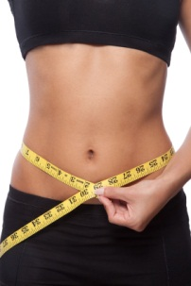
The Lipo-Light offers a safe and effective spot fat reduction solution that can be applied to a multiple of problem areas:
- Waistline
- Mid and lower abdomen
- Upper mid and lower back
- Buttocks and thigh areas
- Arms and underarms

What Should I Expect During a Treatment?

You can relax in a comfortable position while a Lipo-Light technician secures the paddles to the target area. In 10 minute intervals, you are free to relax, read and listen to music.

What Happens After a Treatment?

You are free to resume normal activities immediately after each session—including exercise. Remember: Lipo-Light is safe, noninvasive and you will experience no pain or side effects.
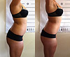
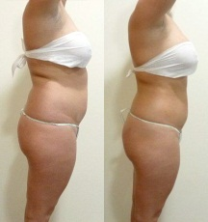

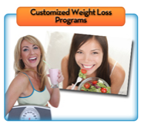

Customized Weight Loss Programs

Have You Tried Every Fad Diet but Still Haven’t Lost Weight?


Or worse – did you lose weight and have it come roaring back shortly after?

The truth is, you might have a specific health issue that is standing in the way between you and your ideal body.

We have GREAT news for you! Thanks to the amazing testing system in our office, we can determine exactly what is keeping you from losing weight.

Together, we will customize a weight loss program specifically for your specific body and your goals. For example, you might benefit from one of the following programs:
- Candida Weight Loss Program
- Hormone Balancing Program
- Sugar Handling Program

We understand how unique your body is and we cater all our weight loss programs to fit you, and only you!

Would you like to experience any of the following…?
- Weight Reduction
- Rid Yourself of Food Allergies
- Increased Energy & Vitality
- Lower Cholesterol
- Improved Digestion
- Improved Physical Appearance
- Clearer Thinking
- Eliminate Headaches
- Clearer Skin


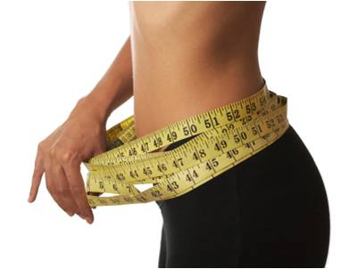



Weight Loss Services

Is Your Body BURNING FAT, STORING FAT, BURNING SUGAR OR STORING SUGAR?

You definitely want it to BURN FAT!

It’s time for you to find out why you aren’t losing your excess weight!

We have amazing tools available to help you get your body into the FAT BURNING MODE!

You can get blood tests, saliva tests, hair analysis, and various other tests to find out what deficiencies you have. Instead, why not analyze what you are putting in your mouth, the activities you are doing and how much sleep and exercise you are getting. Only then can you see what you are missing.

One of the many tools we have in our office is a very complex program that will do all of this for you. All you do is enter all your information, including what you eat and do every day, and press a button. The program then analyzes how these items influence your hormones and gives you instant feedback on what you need to add or change to get your body to burn fat.

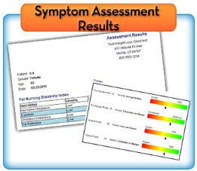
This feedback is specific to you and you’ll meet one-on-one with our staff to explain exactly what your results mean for you. We can get to the bottom of your problems and determine what we can do to help you finally lose your weight, gain more energy!

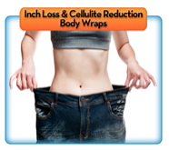

Inch Loss and Cellulite Reduction Body Wraps
Lose 4” to14” in One Hour!

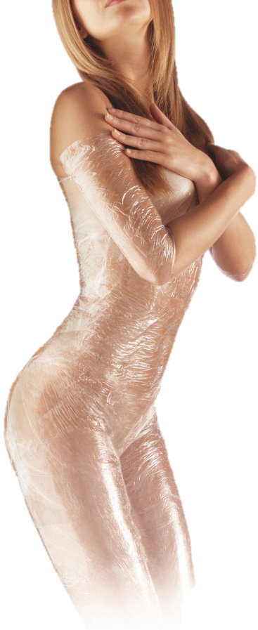
Our Body Wraps are unlike anything you’ve heard about or experienced...

This specific inch loss and cellulite reduction wrap was developed by a bio-chemist from the ULCA medical center. This wrap process was formulated to encourage circulatory and lymphatic flow in patients. Research showed that because of this increased flow of both the lymphatic and circulatory systems, the patients experienced cleansing of the tissues. This, in turn, caused healthy inch loss through internal cleansing.

It’s very typical to lose 4″ to 14″ in one hour. This is NOT weight loss, this is permanent inch loss! Not only does your body benefit internally from this Body Wrap, but the external benefits of contouring and inch loss make this wrap ideal!

Our Body Wraps use herbal formulations which work externally to internally. This type of wrap aids in the removal of wastes that have become trapped in vulnerable parts of your body. It’s basically a painless cleansing process of the tissue underneath the skin, and helps restore elasticity to loose, flabby skin. It does not dehydrate and age the skin. This is the healthiest type of wrap there is!
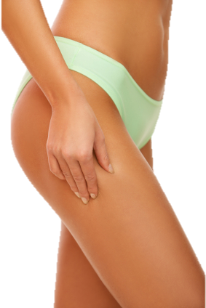
With our Body Wrap you will experience inch loss, diminishing of cellulite, and body contouring. These results can be permanent and are completely safe.

This particular Body Wrap has been helping people lose inches for over 30 years!

Our Body Wraps increase circulation and remove toxins from all areas of your body, two causes of that nasty cellulite!
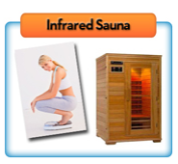

Infrared Sauna

Keep Your Body in Fat Burning Mode to Keep Your Weight Off for Good!

One of our goals is to help you learn how to trigger your fat-burning hormones, this gives you the most effective leverage over fat-burning hormones. Your fat-burning hormones work through your live - that’s why it’s so important to do a cleansing program two to four times a year.

An essential part of cleansing and detoxifying your body is utilizing an Infrared Sauna.

What is Infrared?


Infrared is the band of light you perceive as heat. You can’t see infrared with the naked eye, but you can feel this type of light in the form of heat. The sun produces most of its energy output in the infrared segment of the light spectrum. Infrared rays heat your body without having to heat the air around you.

How Does an Infrared Sauna Aid Weight Loss?

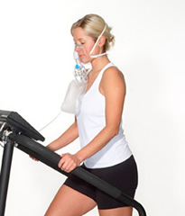
Your body expends energy (calories) to produce sweat - 1 gram of sweat requires approximately 0.586 calories. A moderately-conditioned person can easily sweat of 1000 grams or more in one Infrared Sauna session. That’s the equivalent to running 10-15 kms! While this weight loss can be regained by rehydration with water, the calories expended in the process will not come back. Sweating also allows the body to release built up toxins naturally, keeping your body cleansed even when not on a cleansing program.
How Safe is an Infrared Sauna?

Because infrared is part of natural sunlight, Infrared Saunas are completely safe! Health professionals have used infrared heat lamps for decades to threat muscle and joint problems. In hospital baby care units, incubators are often equipped with infrared heating systems to keep newborn babies warm.

What is the Difference Between an Infrared Sauna and the
Conventional Sauna at my Gym?

Whereas conventional saunas transfer heat by circulating hot air to warm your body from your head down, infrared saunas warm your body directly. This allows an in-depth heat in a more pleasant temperature, thus providing more health benefits and a highly enjoyable and comfortable environment.
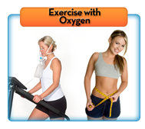

Exercise with Oxygen

Burn More Calories and Make Your Workout Worth It!

Exercising with oxygen therapy (EWOT) can increase strength lines up to 20% and increase weight loss by an additional 20%. EWOT has been known to increase basic cellular life, making you feel 20 years younger!

EWOT increases the amount of oxygen in your blood, plasma and tissues. This increased level of tissue oxygen has several beneficial effects. It has been used successfully for a multitude of conditions, including: heart failure, cardiomegaly, high blood pressure, wellness and anti-aging, emphysema and stress of all types.

How Does EWOT Work?

EWOT allows your body to get more oxygen during your workouts, this in turn gives your body more energy during your workout which can help you push yourself and burn more calories than ever before.

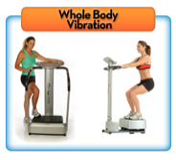

Whole Body Vibration

Accelerate Weight Loss and Cellulite Reduction in 10 Minutes!

What Does Whole Body Vibration Do?

Whole Body Vibration (WBV) offers a low-impacts way to increase strength, flexibility, and rejuvenate your body - in addition to increasing metabolism. WBV causes the muscles to experience an involuntary contraction at the same rate that the platform is vibrating. The mechanical stimulus produces a stretch reflex in 100% of your muscles. This means your muscles react to the vibration by contracting and relaxing automatically (like when the doctor hits your knee with a little hammer).

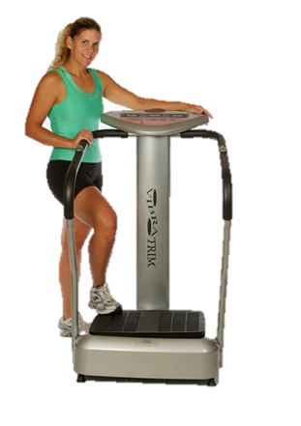
How Did WBV Come About?

WBV training was used in the 1960s by the Russian space program to help cosmonauts recover more quickly from muscle atrophy. Since then, Olympic athletes have adapted WBV into their workouts. Trainers and doctors have been using WBV for well over 40 years.

What Makes WBV Unique?

It’s a noninvasive workout that you don’t have to change into workout clothes for! It’s also a multifaceted tool that complements aerobics and strength training. It’s simply a great tool for a healthy lifestyle!

The Benefits of WBV

- Accelerated Weight Loss
- Reduces Cellulite
- Reduces Varicose Veins
- Increase Energy
- Improves Muscle Strength
- Enhances Wellness
- Enhances Detoxification
- Improves Circulation
- Improves Relaxation

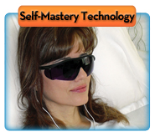

Self-Mastery Technology

Discover What You can Achieve When You Dare to RELAX!

How long have you dreamed of having a trim, fit body… kicking your smoking habit for good… living your life stress free… gaining freedom for your chronic pain… or otherwise changing your life? What if you discovered a way to achieve your goals in just a few minutes a day? Well now you can with an exciting new technology called ZenFrames.

The power of the mind is nothing new to science. Doctors have known for decades that the mind has the power to help people lose weight, stop smoking, manage pain, overcome phobias, accelerate learning, and enhance athletic performance. The only problem was finding a way to harness that potential.

But now there’s ZenFrames, a new technology based on the research of the world’s leading universities.

ZenFrames uses synchronized pulses of light and sound to deeply relax you while promoting optimum brainwave activity for learning, focus and memory. While the lights and tones soothe you, SMT (self-mastery technology) audio-sessions help focus your mind so you can finally release unwanted habits and get more of what you want out of life. And, because the effects are cumulative, there’s virtually no limit to how good you can feel or what you can achieve!

