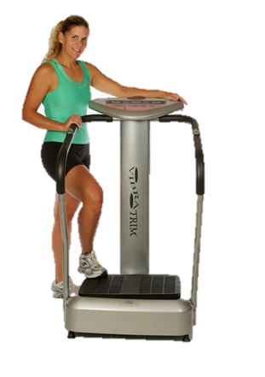
Whole Body Vibration
Whole Body Vibration
For Weight Loss

Accelerate Weight Loss and Cellulite Reduction in 10 Minutes!

What Does Whole Body Vibration Do?

Whole Body Vibration (WBV) offers a low-impacts way to increase strength, flexibility, and rejuvenate your body - in addition to increasing metabolism. WBV causes the muscles to experience an involuntary contraction at the same rate that the platform is vibrating. The mechanical stimulus produces a stretch reflex in 100% of your muscles. This means your muscles react to the vibration by contracting and relaxing automatically (like when the doctor hits your knee with a little hammer).

How Did WBV Come About?

WBV training was used in the 1960s by the Russian space program to help cosmonauts recover more quickly from muscle atrophy. Since then, Olympic athletes have adapted WBV into their workouts. Trainers and doctors have been using WBV for well over 40 years.

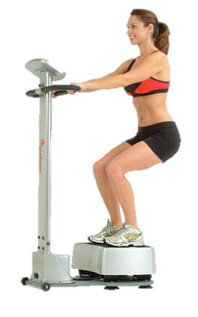
What Makes WBV Unique?

It’s a noninvasive workout that you don’t have to change into workout clothes for! It’s also a multifaceted tool that complements aerobics and strength training. It’s simply a great tool for a healthy lifestyle!

The Benefits of WBV

- Accelerated Weight Loss
- Reduces Cellulite
- Reduces Varicose Veins
- Increase Energy
- Improves Muscle Strength
- Enhances Wellness
- Enhances Detoxification
- Improves Circulation
- Improves Relaxation

