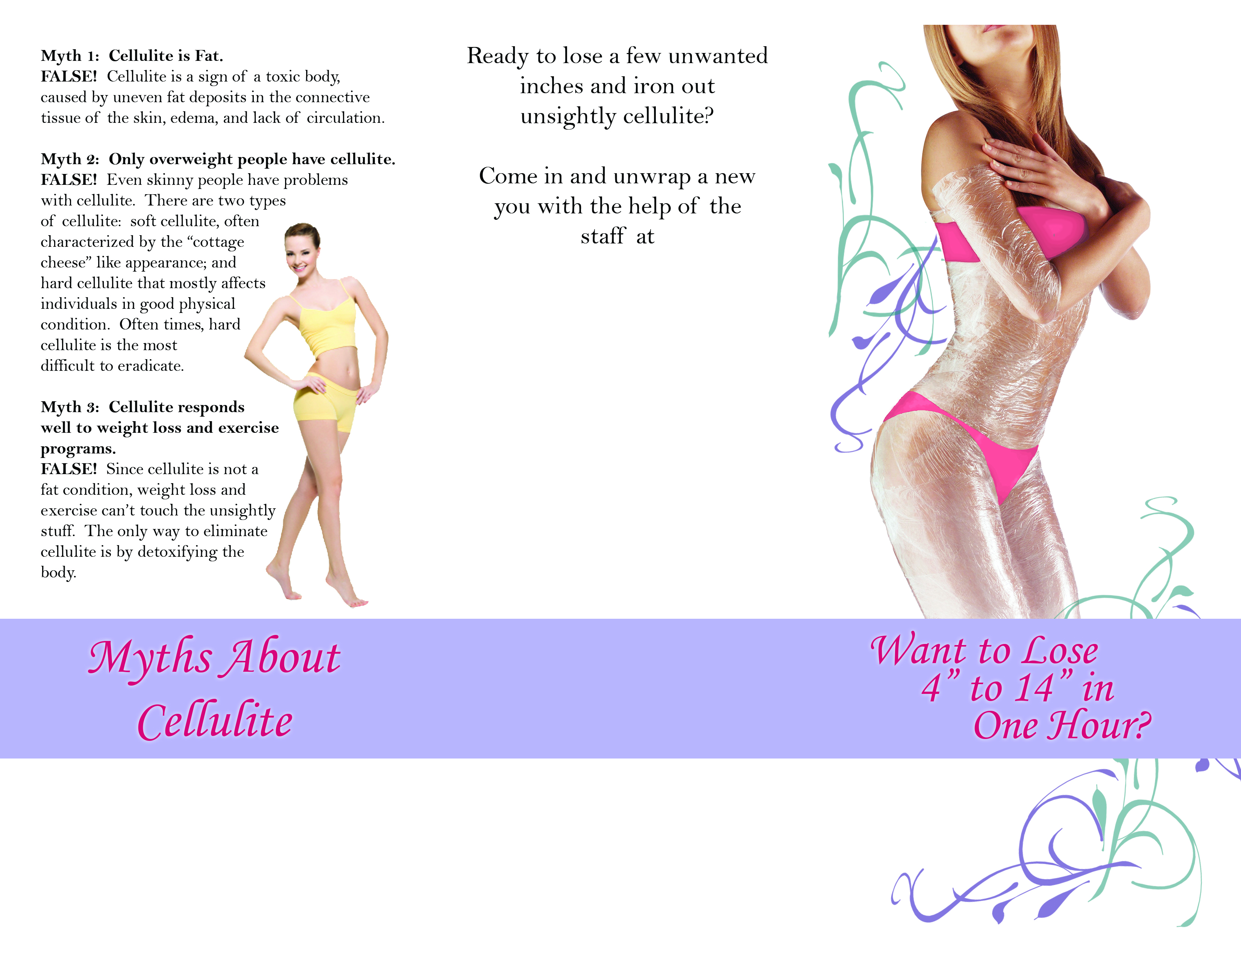
Your Clinic

1234 Main Street
Your Town, ST 12345
Your Hours

1-888-BURN-FAT
YourWebsite.com
Your Logo Here
Your Logo Here

1-888-BURN-FAT
Your Logo Here
1234 Main Street
Your Town, ST 12345

