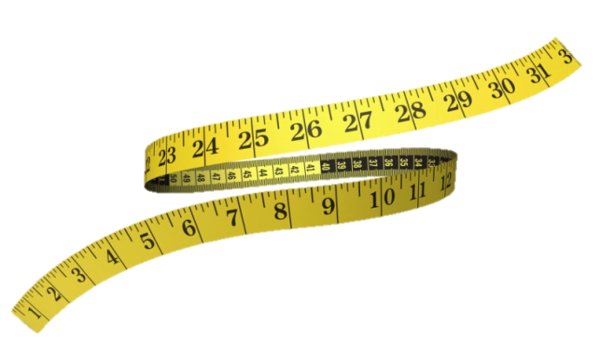
Lose 4” to 14” in One Hour!
Body Wraps

Our Body Wraps are unlike anything you’ve heard about or experienced...

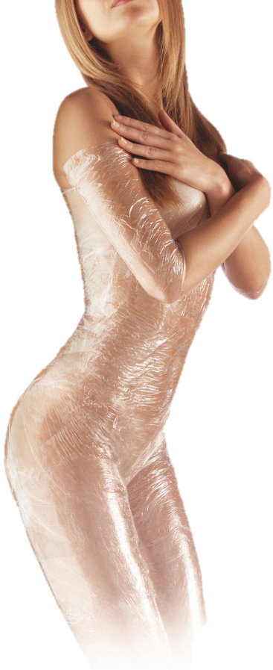
This specific inch loss and cellulite reduction wrap was developed by a bio-chemist from the UCLA medical center. This wrap process was formulated to encourage circulatory and lymphatic flow in patients. Research showed that because of this increased flow of both the lymphatic and circulatory systems, the patients experienced cleansing of the tissues. This, in turn, caused healthy inch loss through internal cleansing.

It’s very typical to lose 4″ to 14″ in one hour. This is NOT weight loss, this is permanent inch loss! Not only does your body benefit internally from this Body Wrap, but the external benefits of contouring and inch loss make this wrap ideal!

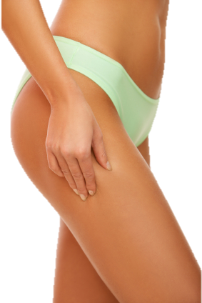
Our Body Wraps use herbal formulations which work externally to internally. This type of wrap aids in the removal of wastes that have become trapped in vulnerable parts of your body. It’s basically a painless cleansing process of the tissue underneath the skin, and helps restore elasticity to loose, flabby skin. It does not dehydrate and age the skin. This is the healthiest type of wrap there is!

With our Body Wrap you will experience inch loss, diminishing of cellulite, and body contouring. These results can be permanent and are completely safe.

This particular Body Wrap has been helping people lose inches for over 30 years!

Our Body Wraps increase circulation and remove toxins from all areas of your body, two causes of that nasty cellulite!

