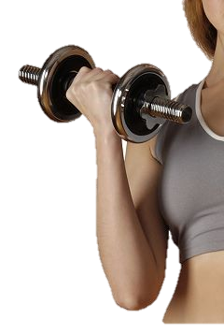
Burn More Calories and Make Your Workout Worth It!
Exercise with Oxygen Therapy

What is Exercise with Oxygen Therapy?

Exercise with Oxygen Therapy (EWOT) is the use of oxygen through a cannula while exerciseing.

How Does EWOT Work?

EWOT allows your body to get more oxygen during your workouts, this in turn gives your body more energy during your workout which can help you push yourself and burn more calories that ever before.

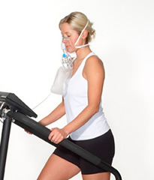
EWOT can increase strength lines up to 20% and increase weight loss by an additional 20%. EWOT has been known to increase basic cellular life making the individual feel 20 years younger, eliminating shortness of breath all together refreshing the whole body with new life. EWOT increases the amount of oxygen in the blood and plasma, and thus also in the tissues.

This increased level of tissue oxygen has several beneficial effects. It has been used successfully for a multitude of conditions, including: heart failure, cardiomegaly (enlarged heart), high blood pressure, wellness and anti-aging, emphysema and stress of all types (surgery, injury, immunizations, smoking, over-exertion, infections, etc.).
It can also...

- Dramatically increase oxygenation of the tissues and cells
- Assist in recovering from stress related illnesses
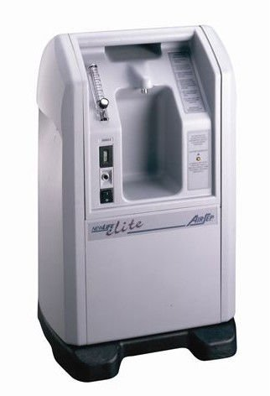
- Prevent age related diseases such as macular degeneration, cataracts, diabetes, chronic fatigue, fibromyalgia (and so much more!)
- Slow down (or Reverse!) the process of aging
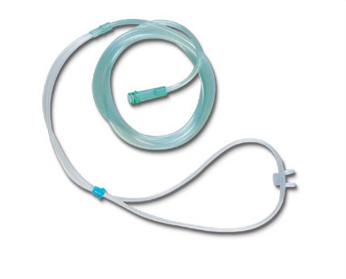
- Increase the diameter of the blood vessels (capillaries) that provide oxygen and nutrients to tissues and cells
- Help in recovering from jet lag
- Stimulate the Immune System
- Accelerate Weight Loss

