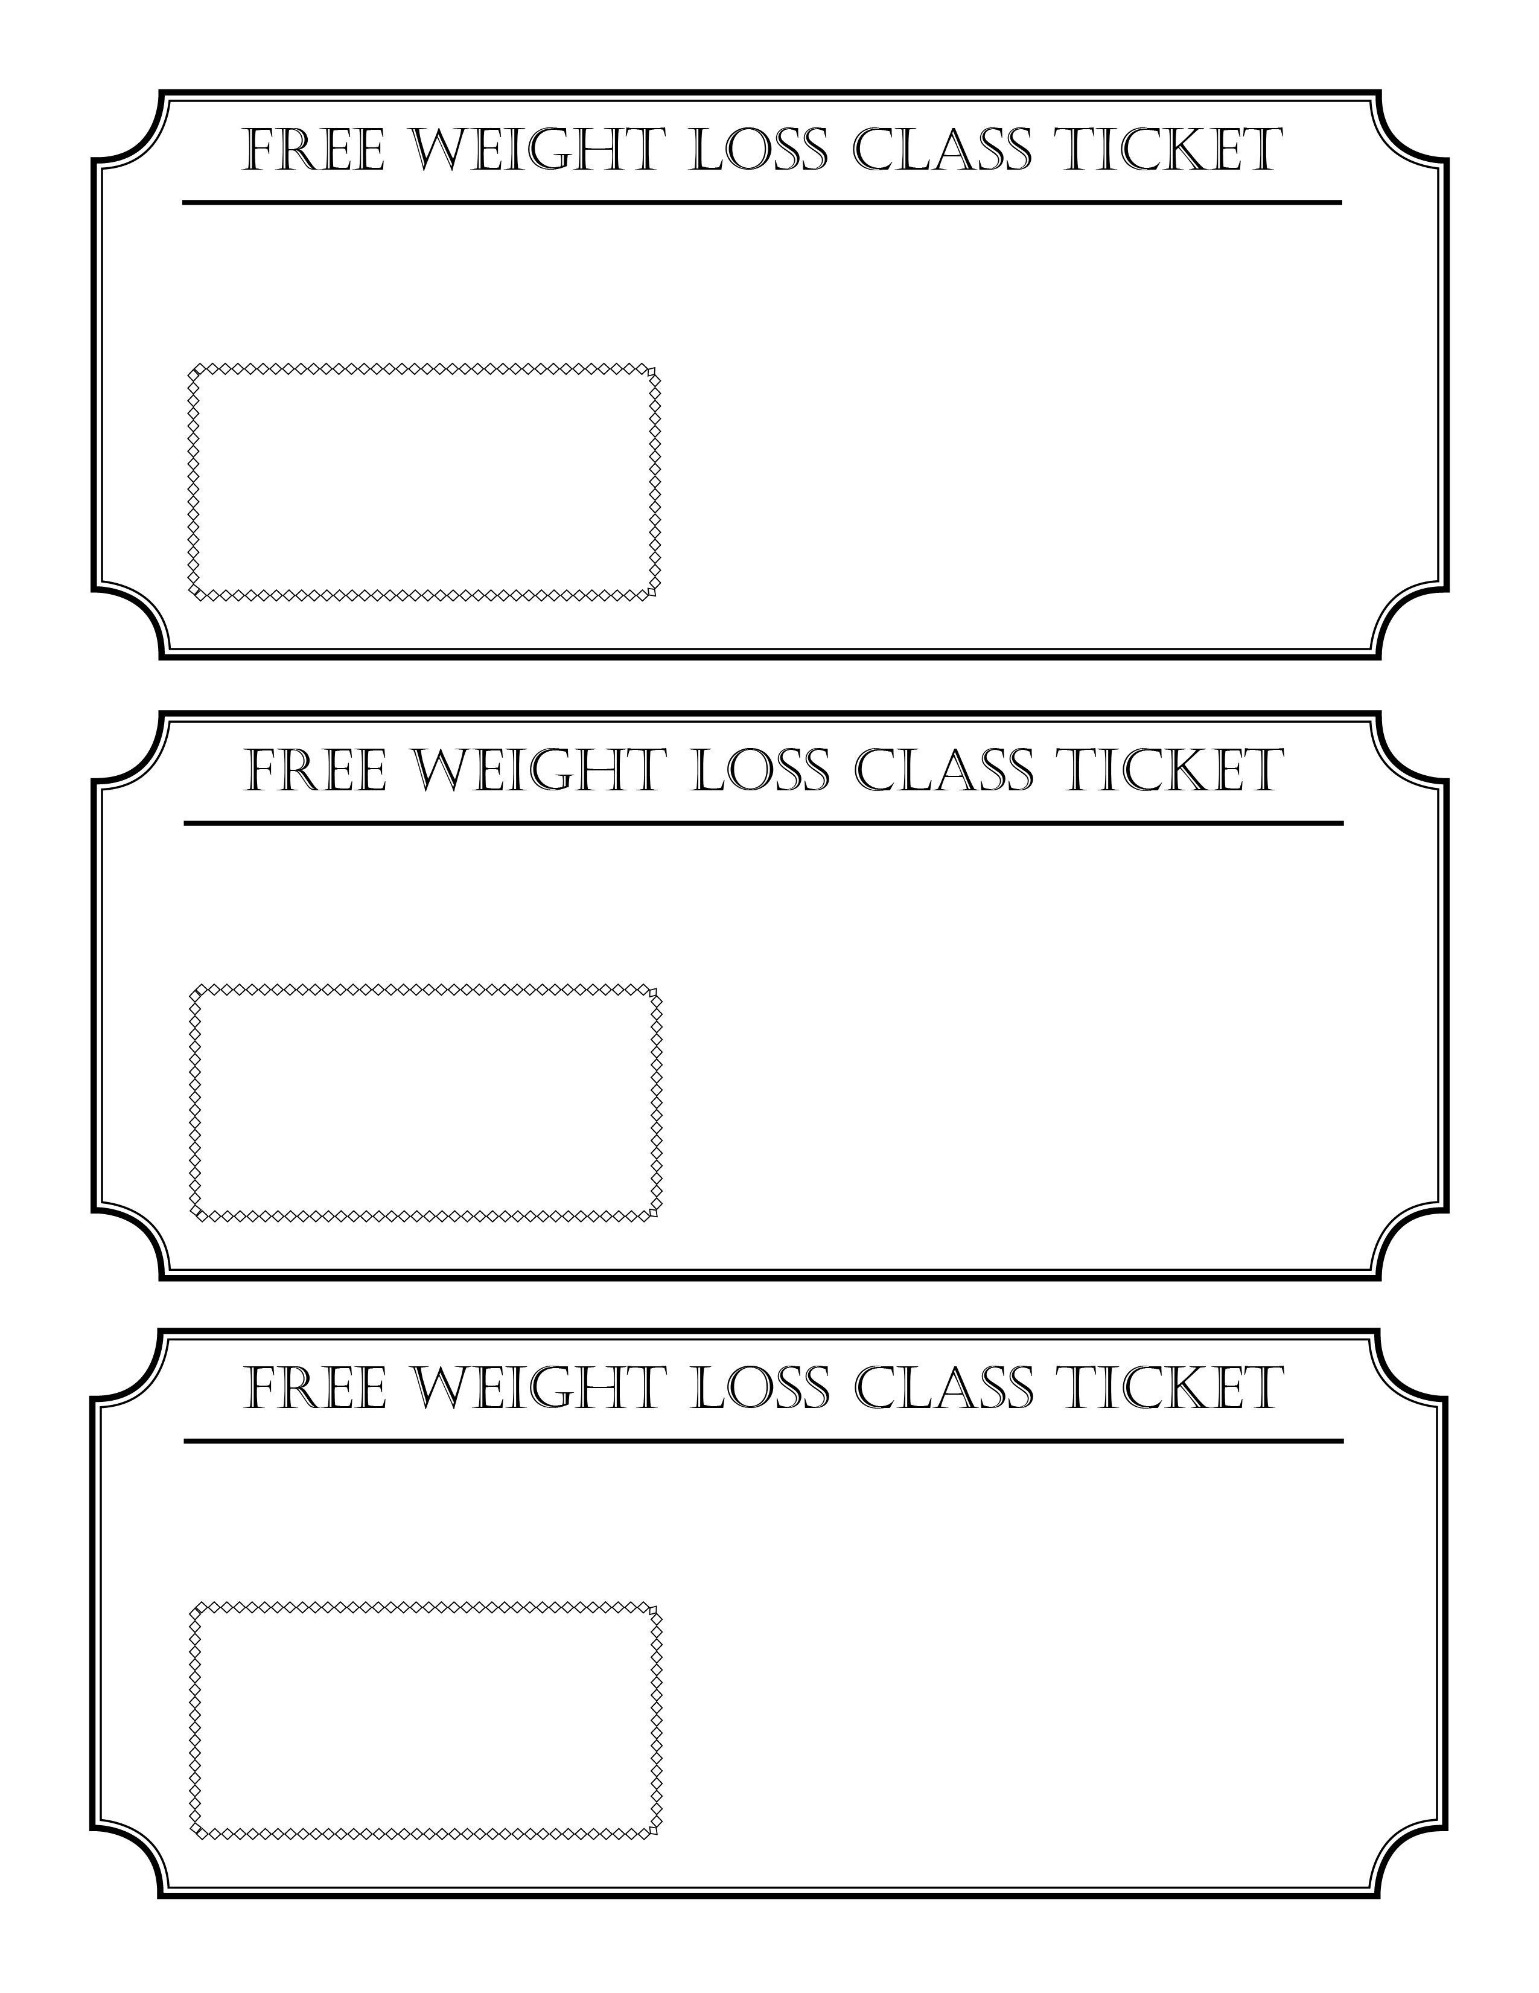
This Ticket is Good for ___ People

Seminar Date: ___________________
Seminar Time: ___________________
Seminar is Located at:
715 E. 3900 S. Ste. #107
Salt Lake City, UT 84107
(801) 265-3400
www.BurnFatUtah.com
You’ll Learn How to Get Your Fat Burning Hormones
Working For You Instead of Against You!
You’ll Learn How to Get Your Fat Burning Hormones
Working For You Instead of Against You!
Seminar is Located at:
715 E. 3900 S. Ste. #107
Salt Lake City, UT 84107
(801) 265-3400
www.BurnFatUtah.com
This Ticket is Good for ___ People

Seminar Date: ___________________
Seminar Time: ___________________
This Ticket is Good for ___ People

Seminar Date: ___________________
Seminar Time: ___________________
Seminar is Located at:
715 E. 3900 S. Ste. #107
Salt Lake City, UT 84107
(801) 265-3400
www.BurnFatUtah.com
You’ll Learn How to Get Your Fat Burning Hormones
Working For You Instead of Against You!

