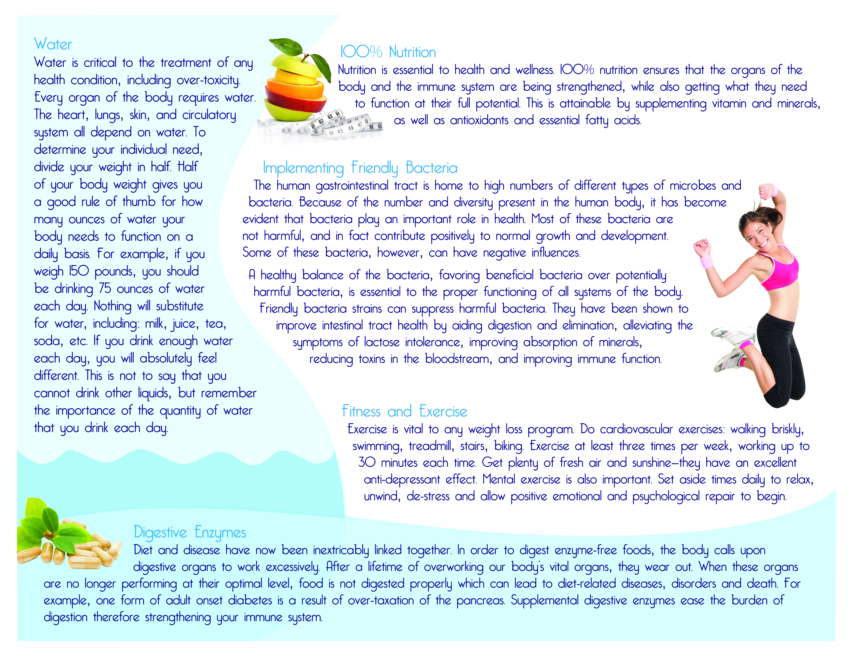

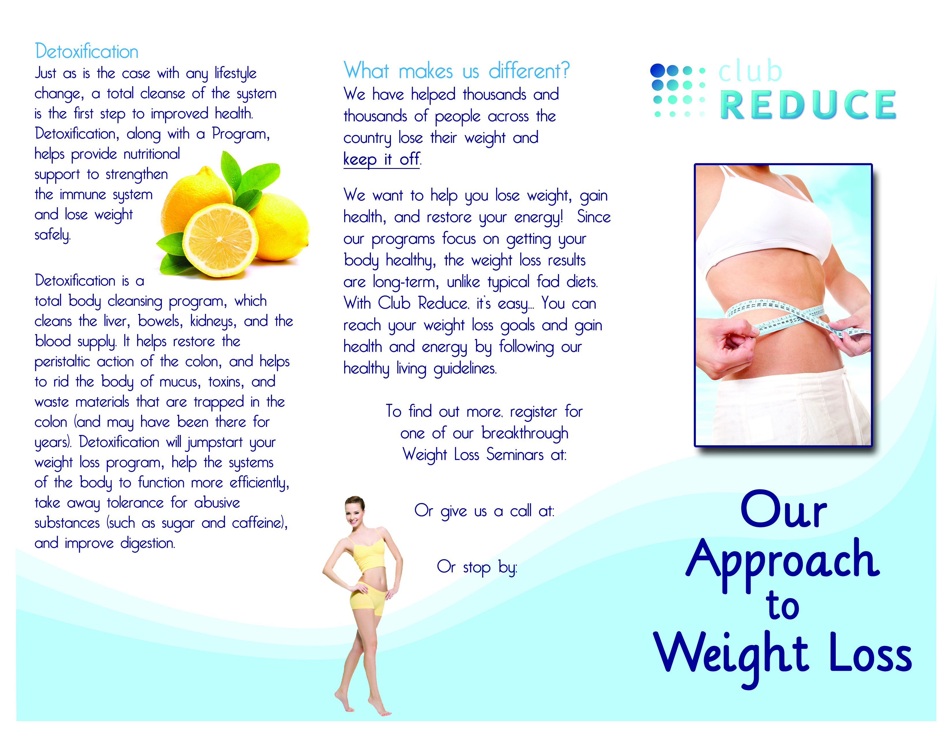
Your Clinic Name
1234 Main Street
Your Town, ST 12345
1-888-BURN-FAT
ClubReduce.com/yourwebsite

