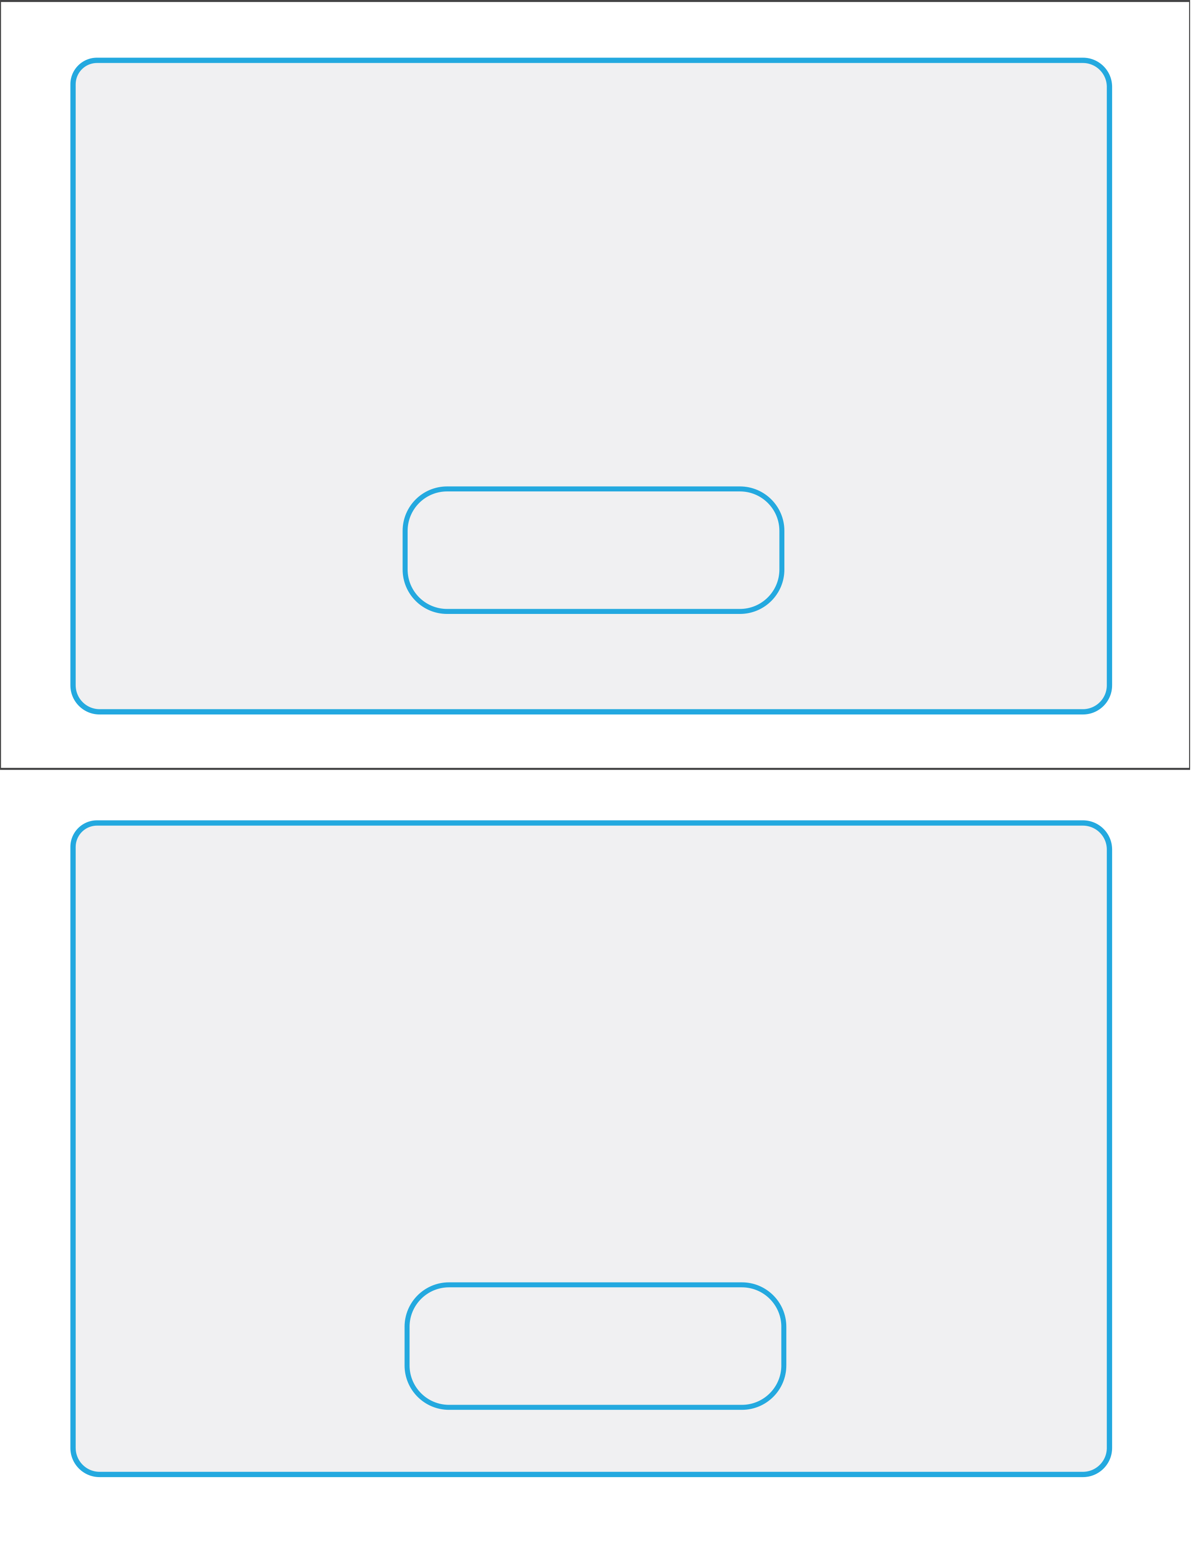
Date & Time of Appointment
Date & Time of Appointment
By Attending this Class and Signing Up Today, You Qualify for a $125.00 Personalized One-on-One Weight Loss Evaluation for only $25.00!
(Offer Good Today Only!)

(Clinic Address and Phone Number Go Here)
REMINDER FOR APPOINTMENT
Name:______________________________________________________

By Attending this Class and Signing Up Today, You Qualify for a $125.00 Personalized One-on-One Weight Loss Evaluation for only $25.00!
(Offer Good Today Only!)

REMINDER FOR APPOINTMENT
Name:______________________________________________________

Return this copy to us tonight
Form of Payment: Cash Check Credit Card
(Clinic Address and Phone Number Go Here)

