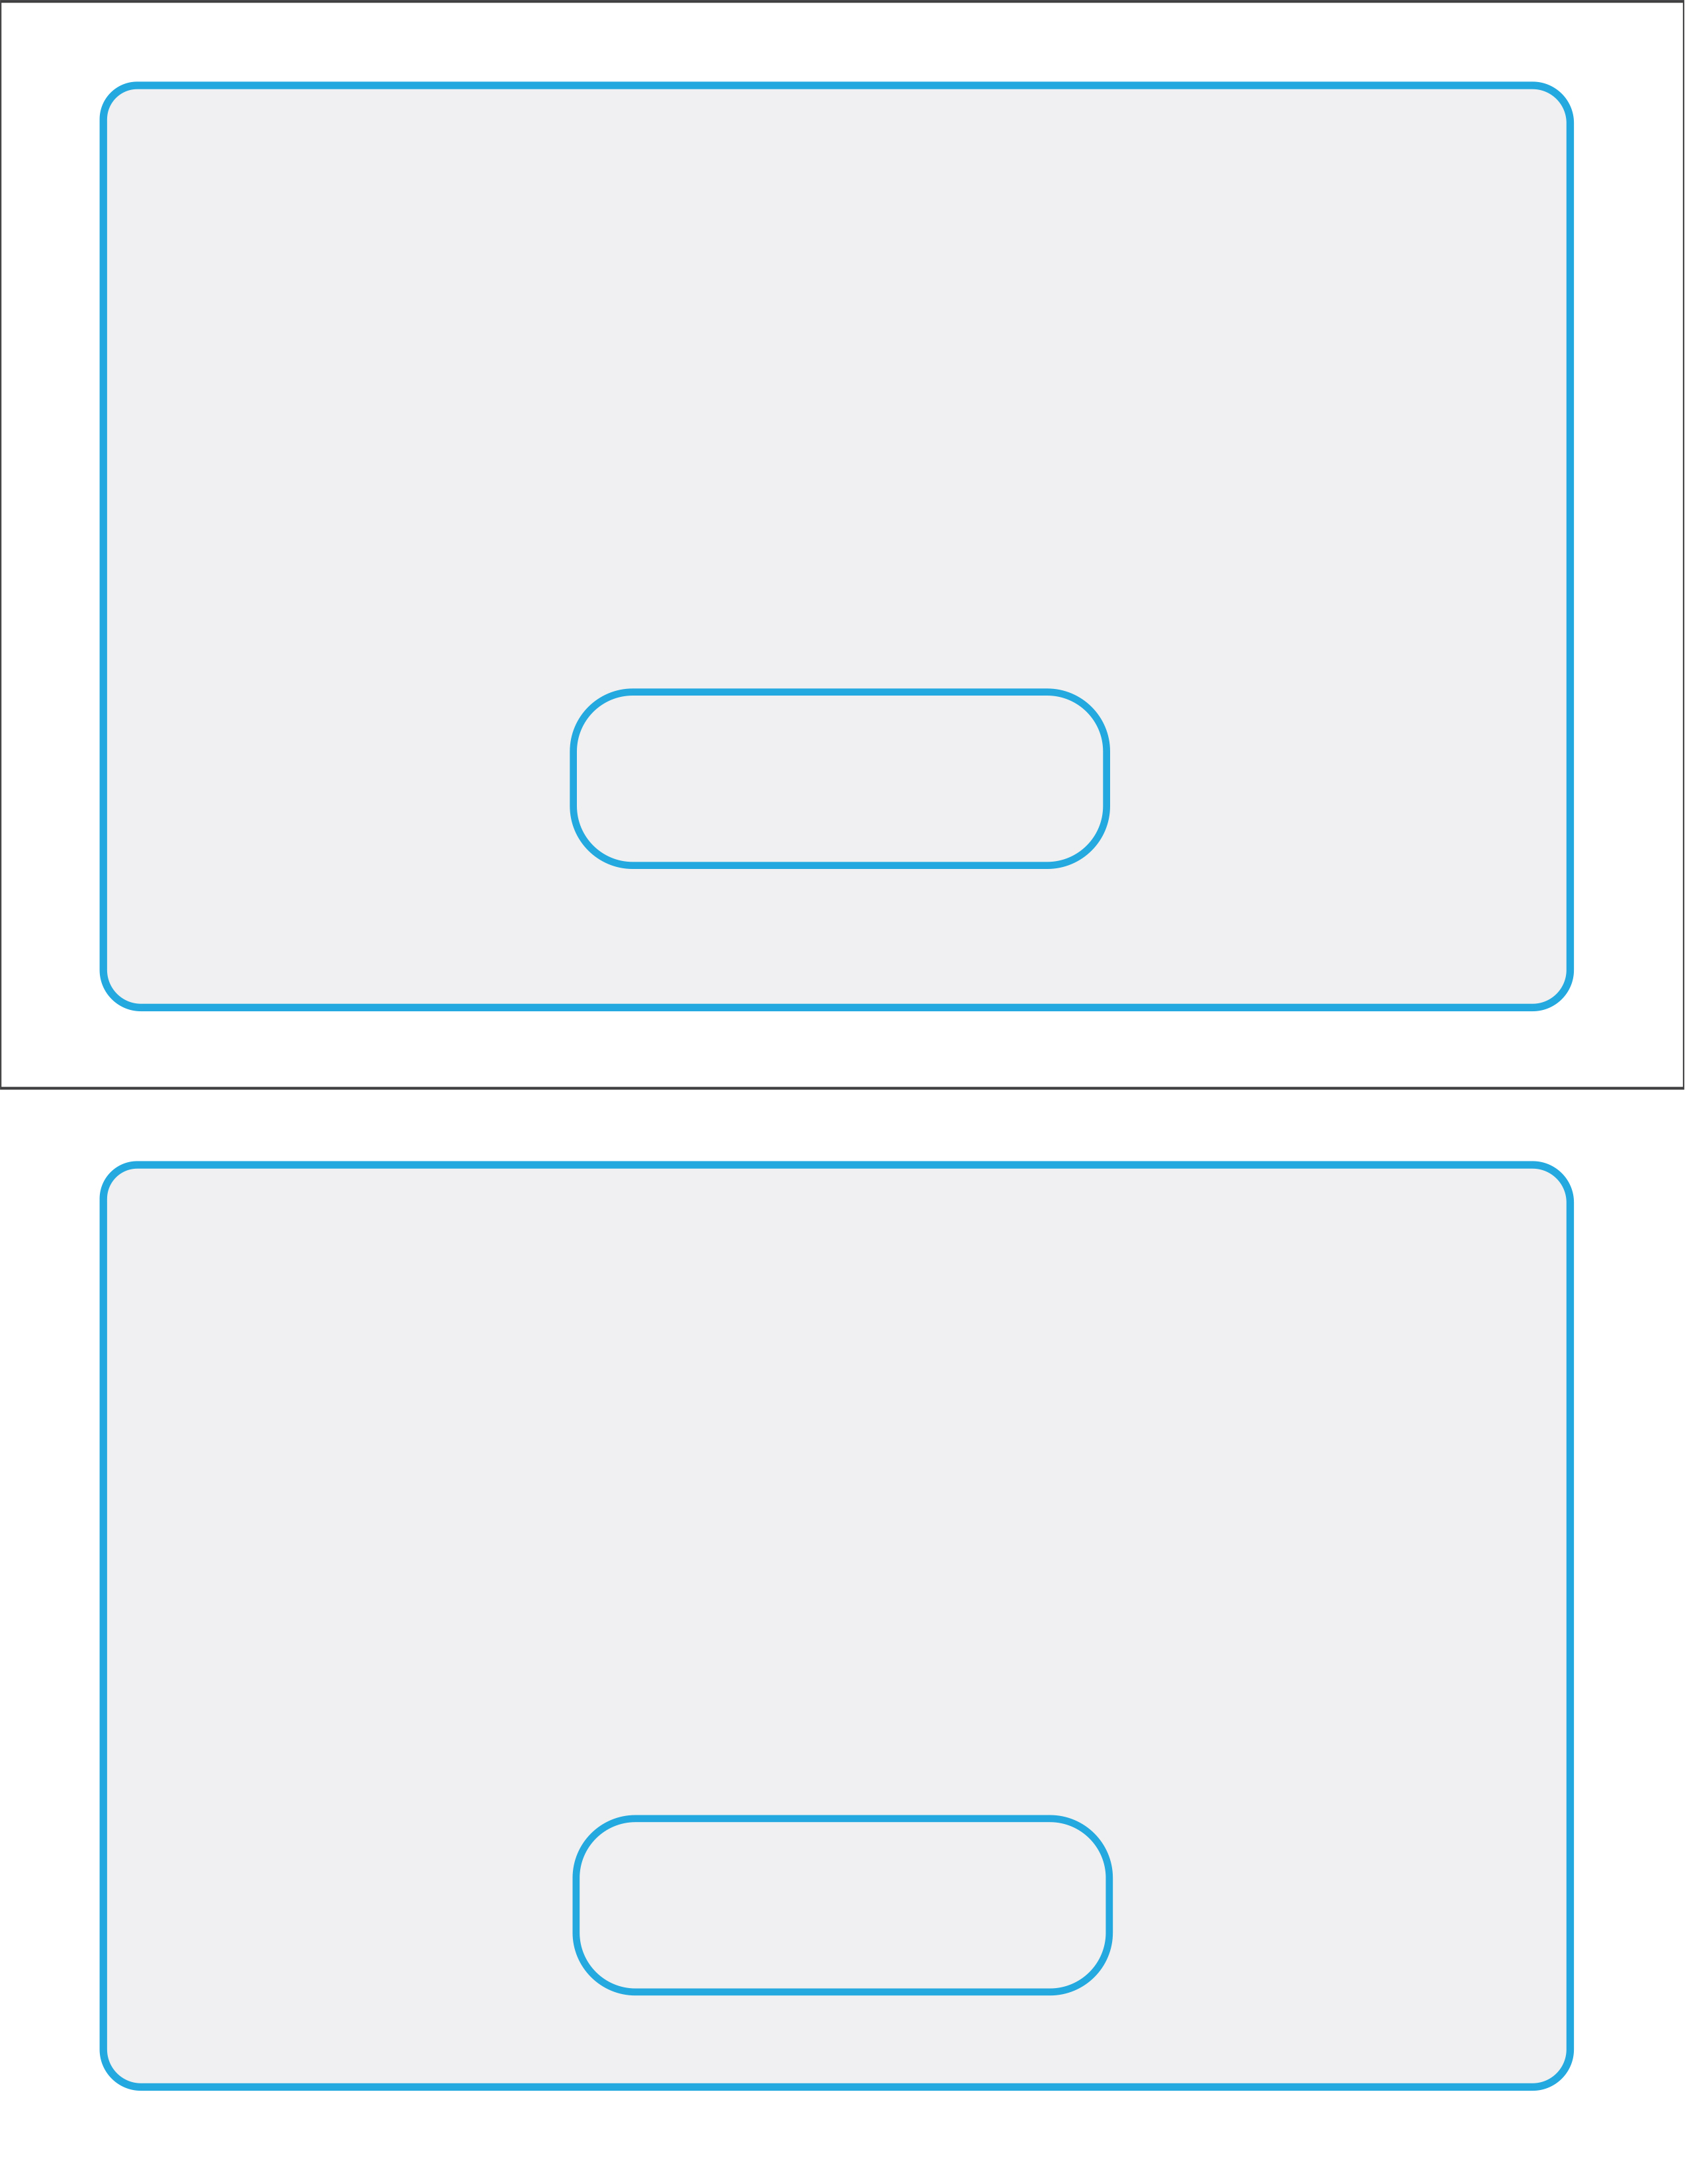
Date & Time of Appointment
Date & Time of Appointment
By Attending this Class and Signing up Today, You Qualify for a Free Personalized One-on-One Weight Loss Evaluation ($125 value)!
(Offer Good Today Only!)

(Clinic Address and Phone Number Go Here)
FREE ONE-ON-ONE EVALUATION
Name:______________________________________________________

By Attending this Class and Signing up Today, You Qualify for a Free Personalized One-on-One Weight Loss Evaluation ($125 value)!
(Offer Good Today Only!)

FREE ONE-ON-ONE EVALUATION
Name:______________________________________________________

Return this copy to us tonight
Form of Payment: Cash Check Credit Card
(Clinic Address and Phone Number Go Here)

