
Lipo-Light Treatment
Why was it designed?
The Lipo-Light was designed to specifically address spot fat reduction or inch loss and body contouring. It is administered in relaxing 10-30 minute sessions. There is no surgery or pain or extensive recovery time.

Who is an Ideal Lipo-Light Candidate?
The Lipo-Light is the ideal treatment for all body types when combined with a healthy diet and lifestyle. It works synergistically with the body’s natural weight loss mechanisms. It specifically targets troublesome areas to remove inches.

How Does a Lipo-Light Work?
The LED energy safely penetrates the skin targeting the fat cells (Subcutaneous layer). Once the cells are permeated, they release fatty acids, water and glycerol, or triglycerides. The triglycerides are released from the fat cells and the body uses them as an energy source. The fat cells then “shrink” significantly resulting in inch loss and the removal of cellulite.

Where Can the Lipo-Light Be Used?
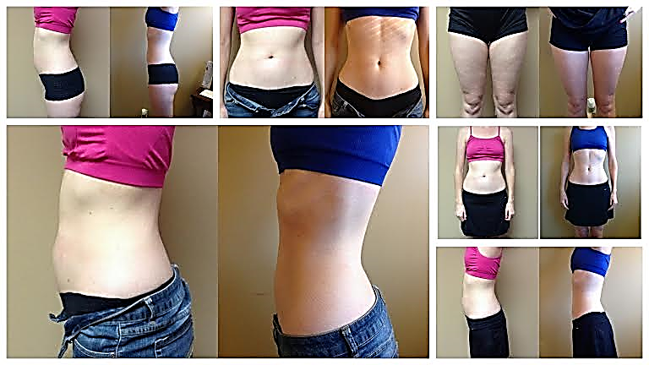
The Lipo-Light offers a safe and effective spot fat reduction solution that can be applied to a multiple of problem areas:
- Waistline
- Mid and lower abdomen
- Upper mid and lower back
- Buttocks and thigh areas
- Arms and underarms

What Should I Expect During a Treatment?
You can relax in a comfortable position while a Lipo-Light technician secures the paddles to the target area. In 10 minute intervals, you are free to relax, read and listen to music.

What Happens After a Treatment?
You are free to resume normal activities immediately after each session—including exercise. Remember: Lipo-Light is safe, noninvasive and you will experience no pain or side effects.

- Our Lipo-Light utilizes LED light technology for spot fat reduction, inch loss and body contouring in almost any area of the body.
- The Lipo-Light is 100% noninvasive, with no known side effects.
- The Lipo-Light was designed to specifically target subcutaneous fat, reducing the appearance of cellulite, resulting in inch loss and body contouring.

Inch Loss and Cellulite Reduction Body Wraps
Lose 4” to 14” in One Hour!
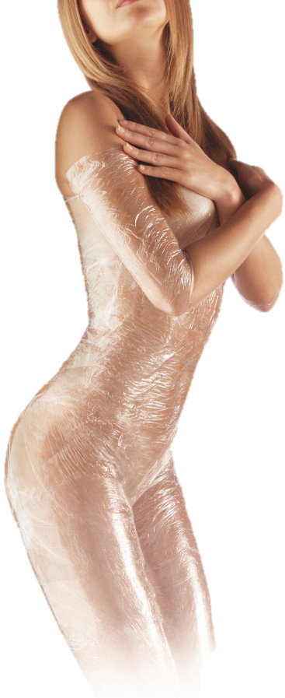
Our Body Wraps are unlike anything you’ve heard about or experienced...
This specific inch loss and cellulite reduction wrap was developed by a bio-chemist from the ULCA medical center. This wrap process was formulated to encourage circulatory and lymphatic flow in patients. Research showed that because of this increased flow of both the lymphatic and circulatory systems, the patients experienced cleansing of the tissues. This, in turn, caused healthy inch loss through internal cleansing.
It’s very typical to lose 4″ to 14″ in one hour. This is NOT weight loss, this is permanent inch loss! Not only does your body benefit internally from this Body Wrap, but the external benefits of contouring and inch loss make this wrap ideal!
Our Body Wraps use herbal formulations which work externally to internally. This type of wrap aids in the removal of wastes that have become trapped in vulnerable parts of your body. It’s basically a painless cleansing process of the tissue underneath the skin, and helps restore elasticity to loose, flabby skin. It does not dehydrate and age the skin. This is the healthiest type of wrap there is!
With our Body Wrap you will experience inch loss, diminishing of cellulite, and body contouring. These results can be permanent and are completely safe.
This particular Body Wrap has been helping people lose inches for over 30 years!
Our Body Wraps increase circulation and remove toxins from all areas of your body, two causes of that nasty cellulite!

- Wear something you are comfortable in, Remember the more skin you show the more we can wrap.
- Drink a lot of water before and afterward.
- Try not to shower until 8 hours after your wrap, the cream is still penetrating into your skin.
- Do not shave the day of your wrap, we use an exfoliator and it is not good to double exfoliate the same day.

