“7 Simple Steps You Can Take to Kick Start Your Fat Burning Hormones and Change Your Body Forever!”
But Don’t Take Our Word For It, Read Below and Inside to Learn Why You May Not Be Triggering Your Fat Burning Hormones... and How Thousands of People Like You FINALLY LOST THEIR WEIGHT!

Meet Suzanne: “I Tried So Many Other Programs…”

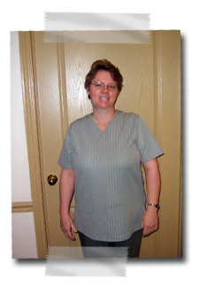
What was life like before Lighthouse Health?
“During the summers, I had a difficult time keeping up with my
kids – right about noon I would crash and burn, but of course the kids never stopped. I tried so many other programs and I would just end up frustrated with the lack of results.”

How has your life changed since coming to Lighthouse Health?
“Yes, I can finally function like a normal person! My clothes from before don’t even fit and people have started asking what I’ve been doing because I look so fabulous. The doctor was even
able to help my family – my kids no longer suffer from different ailments, life is great!”

Suzanne
before


Meet Julianne: “My Life has Changed Dramatically!”


After:
LOST 26 lbs!

What was life like before Lighthouse Health?
“I was so sick I couldn’t even make it through the day. Sure I had a weight problem, but it didn’t compare to the miserable migraines I dealt with daily. I had tried every ‘miracle diet pill’ known to man and nothing worked – in fact, they made the problem worse!”

How has your life changed since coming to Lighthouse Health?
“My life has changed dramatically and I couldn’t be happier! Not only did I finally lose the weight I wanted to, but I got truly healthy. No more headaches, no more body aches and pains – it feels great to finally be able to LIVE again!”

Julianne
before


After:
LOST 25 lbs!
Meet Don: “I Could Never Make It Through the Day…”

What was life like before Lighthouse Health?
“I had terrible heartburn and I could never sleep soundly through the night. I was always exhausted and I could never make it through the day.”

How has your life changed since coming to Lighthouse Health?
“Not only did I lose over 31 pounds, I no longer have problems with heartburn – not to mention I can finally sleep through the night. I can finally keep up with all the young guys at work! People have even started noticing the difference and asking me what’s up. I tell them all it is thanks to these programs from Lighthouse Health!”

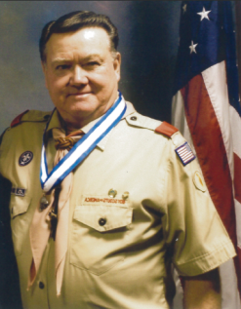

Don
before
After:
LOST 31 lbs!

“Who Else is Ready to FINALLY Lose Weight and Have the Health and Energy You So DESPERATELY Want?”

At Lighthouse Health and Body Makeover, you will discover all the tools to help you
maximize your weight loss and then keep it off permanently!

Every dieter’s dream!
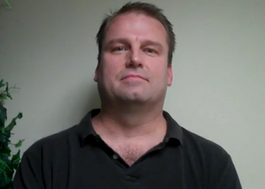 | “I was 310 pounds and not really feeling good about anything, the way I looked, the way I felt. I was searching for a change. I felt that when I started this program it fit right in with that. My life has completely turned around since that’s happened! And I’m not really doing anything different. I have the same job. I earn the same money. But I’m happier!”
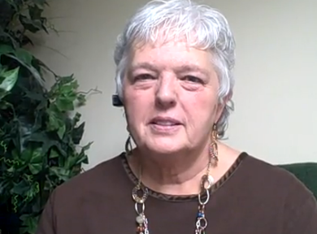 | “I came here to see Dr. Singleton three months ago and he told me he could help me lose 40-50 lbs in three months. I didn’t believe it. But this was my last chance and then I was going to try lap-band surgery. So I gave him three months and… I lost 55 pounds! I am so happy! I can’t even tell you how happy I am. I am ecstatic.”
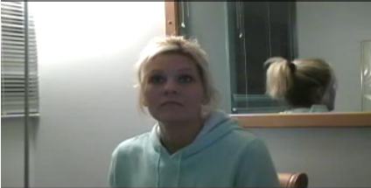 | “When I started, I was drinking about 12 Diet Pepsi a day and now I haven’t had any for weeks! I don’t eat fast food anymore. I cut that out totally. I eat fruits and vegetables and chicken. I have lost quite a bit of weight. A lot in my face and in my pants. My boyfriend even noticed!”
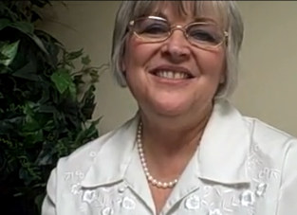 | “I’m 57 years old. I was well over 200 pounds two months ago. I started the Candida program. It’s the first program out of a 100 different programs I’ve tried that has worked for me! I’ve lost two pants sizes, 25 pounds, and I’ve gotten loads of compliments. My skin, my hair, my vitality is all over the top.”
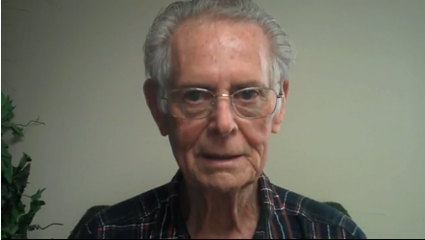 | “I’ve just checked out my weight and I found that I’ve lost as much as 20 lbs over the last 8 weeks and I’m feeling great. I feel like I am 35 years old. I am 83 years old and I have a good, strong, healthy life ahead of me and I know it and I appreciate it.”
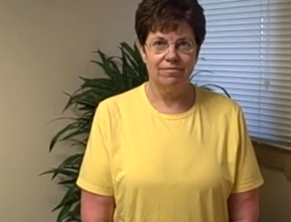 | “I came to Lighthouse Health to do the 12-week program. I had tried to lose weight for the last ten years. I did a lot of different programs. I’d lose weight and gain it back. I came to improve my overall health. I was feeling extremely stressed out. I found the program here to be very extensive. Probably the best part about it is that it gets to the root issue! I’m feeling much better. I’ve lost 36 pounds and I’m looking forward to a much healthier life.”
Why should you listen to us? What makes this system so very different…

“Our Goal is to Help You Find Out Just What’s Keeping Your Body from Burning Fat and Then Help You Balance Your Body Naturally and Keep Your Weight Off!”

Traditional diet plans take a one-size-fits-all approach and never uncover why your weight got there in the first place.

- Have you failed at dieting?

- Do you exercise with little or no weight loss results?

- Do you crave sugar, salt and fat?

- Do your cravings sometimes seem to control you?

- Have you noticed that you can’t shed weight the way you once did?

- Do you have weight-related health issues such as pre-diabetes, diabetes, or high cholesterol?

- Do you seem to gain back your weight faster than you lose it?

- Do you find it difficult to see yourself at your ideal weight?

- When you lost weight in the past, did you feel like a “thin” person with a “fat” mind?

- Do you want to feel attractive again?

- Is it about time you did something for YOU?

If you said yes to any of these questions and you have a burning desire to lose weight and keep it off… You Must Read the Following 7 Steps!

When your body is in proper balance, your fat burning hormones will be functioning properly.

How can you get your body in proper balance and kick start your fat burning hormones?

Well……
Step 1: “Complete a Simple To-Fill-Out Test that Will Reveal

the Real Reason YOUR Body is Not Losing Weight!”

You are an individual and therefore you need your own individualized program!

You need a program that has been customized by doctors to specifically meet your needs.

If you don’t understand how your body is unique, you won’t lose weight.

You must answer the question: Why Haven’t You Been Able to Lose Weight and Keep It Off?

We would love to help you determine what has been stopping you from losing weight!

We’ll give you a thorough “Symptom Assessment” so you can discover once and for all, the reason you’ve not been able to lose your weight and keep it off!
(No blood tests or invasive diagnostics required!)

Our thorough and comprehensive assessment helps you understand your body and why you haven’t been able to lose weight and keep it off.

Many doctors and many years of work went into developing this phenomenal assessment!

Since then, it has been used by thousands and thousands of patients.

Taking this thorough assessment in our office usually costs $125.

But! Since you requested this report, we’ve enclosed a coupon for FREE attendance to our weight loss seminar plus a one-on-one personalized weight loss evaluation, where you will be able to take this amazing “Symptom Assessment” and start on your journey to finally lose your weight and keep it off!

Our weight loss seminar will go into detail on how you can proactively
get control of your weight and get your fat burning hormones working to help
you lose your weight!

You need to find out what it is that is prohibiting you from losing weight!

Take the First Step…

Find out what your symptoms say about YOU!

Come to our clinic, Lighthouse Health, and start losing your weight by completing this easy, but comprehensive assessment for FREE!

Keep reading and we’ll tell you how to redeem this killer deal!

Step 2: “Get Help…If You Could Have Done this By Yourself By Now,
You Would Have!”

Hey, that’s okay! Even professional athletes rely on a coach!

More than likely this is not the first place you’ve looked for a solution to your weight problems.

You’ve tried on your own, and haven’t been able to lose your weight and keep it off.

We’ve found that something MAGICAL happens when you have someone “holding your hand” through this process!

Think back to school…you did what your teacher assigned you to do. And by doing what your teacher assigned, you were able to graduate.

Can you imagine leaving a small child on their own and expecting them to do what was required to graduate from high school without a parent or a teacher as a coach...well that’s laughable...we know it wouldn’t happened...

Likewise, you shouldn’t be surprised that you haven’t been able to lose your weight on your own.

Sure you might think it’s simple, but after trying all of these times and failing, you can now see that you need to find out WHY you can’t lose your weight and you need an accountability coach to help you succeed once and for all!

Lucky for you, the biggest difference between our program and others is that we are here to be your accountability partner.

Look, the simple truth is you need somebody to help you, someone who has the necessary experience and expertise.

We have helped thousands and thousands of people kick start their fat burning hormones and
lose their weight just by being their partner in the process and helping them all along the way!


- We’re offering to hold your hand through your weight loss journey!

- We will be the one you turn to when you feel you can’t go on…

- Look, if you didn’t need this help, you wouldn’t be reading this!
So the first thing you need to do is…

Attend our weight loss seminar that goes into detail on how
our accountability system will work for you!

And by attending the weight loss seminar, you will receive a FREE
One-on-One Personalized Weight Loss Evaluation where you will get to
take the incredible “Symptom Assessment” and find out exactly why
you haven’t been able to lose your weight! (See attached coupon!)

We know this program works, so we are here to say, “You can do it, of course you can…others have…now it’s your turn…come on, do it!”

Step 3: “Discover Specific Foods that Cause Your Body to Store Fat!”


Here are some brutal facts you may not know….

- Statistics show that 66% to 86% of American adults are overweight!
- Statistics show that 90% of adults will be overweight by the year 2030!
Why are so many people overweight???

More often than not it’s because they don’t understand how the food
they’re choosing to eat is affecting their bodies.

Did you know food can be as addictive as drugs or alcohol? It CAN!

Did you know in most cases, overeating, cravings, and lack of energy are
caused by nutritional imbalances in your system?

It might be hormonal. It might be a sluggish metabolism. Or it might be too much yeast.

But how would you know?

You need to find out which foods trigger a negative reaction in your body!

Certain foods will trigger your body to store fat instead of getting rid of it.

The simple truth is there are certain foods you should eat and certain foods you shouldn’t.

We actually have a phenomenal seminar that tells you what they are!

During the seminar, you will learn about certain foods that cause your fat burning hormones to work for you…

And certain foods that put you into fat storing!

After the seminar, you’ll be given the opportunity to sign up for a
One-on-One Personalized Weight Loss Evaluation, where…

WE WILL SIT DOWN WITH YOU AND COME UP
WITH A COMPLETE LIST OF ALL YOUR
TRIGGER FOODS!

This “One-on-One Personalized Weight Loss Evaluation” is typically $125 in our office, but again, with this offer, you are getting a coupon to 1) Attend the Breakthrough Weight Loss Seminar, 2) Take the “Symptom Assessment” and 3) Have a One-on-One- Personalized Weight Loss Evaluation….all for FREE!

Your FREE COUPON is INCLUDED in this OFFER!

Step 4: “Find Out if Your Exercise (or Lack of it) is Making you Fat!”

Did You Know There are Certain Types of Exercise that Put you in Fat Storing Mode…
and Others that Put You in FAT BURNING MODE?

It might not be what you think!!!

Did You Know You Have Fat Burning Hormones that Won’t Work
if You Don’t Exercise Properly?

If you think you have to exercise for a LONG time each day and that you just won’t be able to do it…you’d be wrong!

When you come in and we sit down with you in your “One-on-One Personalized Weight Loss Evaluation” we will reveal the specific types of exercise that will work best for you!

It will be almost too EASY to incorporate these types of exercise into your weekly workout.

The exercise we recommend is efficient and there’s no equipment necessary! There will be no need to go crazy trying to fit grueling hours at the gym into your schedule.

You can adapt it to whatever time and space constraints you have!


Soon you’ll be amazed at your growing strength and success!

What are the benefits of the exercise you will soon be doing?

For starters, you will…

- trigger your fat burning hormones!
- kick start your body into fat burning hyper drive!
- burn calories quicker!
- continue to burn calories in the 24 hours after your workout!
- lose weight, not muscle!
- increase your metabolism!
- slow down the aging process!
- have a healthier heart!
- have less risk of high blood pressure and heart disease!
- greater physical strength!
- AND BETTER WEIGHT LOSS RESULTS!!!
We can help you to know what the BEST TYPE OF EXERCISE IS FOR YOU!

During your FREE (normally $125) “One-On-One Personalized Weight Loss Evaluation” we will explain exactly what you need to do!

Finish reading the 7 steps to find out how you will be able to get your FREE personalized evaluation!

Step 5: “Re-evaluate Your Goal…Losing Weight Short-Term isn’t Good Enough Any More…This Time, Your Goal Must be to Lose Weight, Keep it Off and Gain the Health and Energy You’ve Always Secretly Desired!”

The Weight Loss System We Use at Lighthouse Health was
Specifically Designed by a Doctor for His Patients Who had
Been Struggling for Years with Stubborn Weight Loss Problems!

Now years later, hundreds of thousands of patients around the country have been introduced
to this system and have finally been able to lose their weight and get healthy along the way!

You see, most weight loss programs out there focus on one thing: Weight Loss!

Sure everyone wants to lose weight….and there are thousands of fad weight loss diets that might work for a day or a week or even a month!

The problem is these programs don’t focus on the real prize….getting healthy and feeling great! There are a lot of thin people out there who are also sick, tired, lethargic, moody, unhappy, unhealthy and still looking for answers!

The difference with this program is that the doctor who started it spent 20 years watching patients gain and lose and gain and lose…and remain unhealthy…and he was determined to put a stop to that craziness once and for all!

So the result of the program is that YOU WILL LOSE YOUR WEIGHT AND KEEP IT OFF, but the real goal is to finally get you feeling GREAT!

The real goal is for you to have VIBRANT ENERGY, so you can
THINK MORE CLEARLY, SLEEP BETTER and even BE MORE CHEERFUL…
because this system will even affect your mood in a positive way!

If you are willing to do the work and go on a program to finally lose your weight, why in the world wouldn’t you also want to regain your health along the way!

At Lighthouse Health, we are going to help you lose your weight AND get healthy along the way!

When you come in for your FREE “One-on-One Personalized Weight Loss Evaluation” we will explain to you exactly what you need to do to get started on your journey to weight loss, vibrant energy, and health!

We will Sit Down with You and Come Up with a Complete Customized Plan to Help You Lose Your Weight and Gain Your Health!

But first, you will need to attend our amazing Breakthrough Weight Loss Seminar…keep reading for details of what you need to do to attend…

Step 6: “Find Out What Essential Nutrients Your Body is Lacking
in Order to Burn Fat!”

Your body needs certain vitamins and minerals in order to burn fat…it’s just that simple!
You should be able to get these nutrients your body needs to work properly and stay in “fat burning mode”…

However, it’s time to face the facts. The food supply in America is not what it once was!

- The soil is so depleted and the food is so over-processed and filled with chemicals and pesticides that there’s no way to get all the nutrients you need.
- Vitamins and nutrients that should be in our food are not.
- Foods are so over-processed that almost all of the nutrients are depleted!
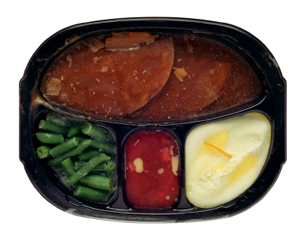
Not only that, but as a result of modern production techniques, there is a whole new breed of health-harming ingredients that can be found in typical store-bought food.

They include: •Processed Salt •Soy •High Fructose Corn Syrup •Preservatives
•Treatment agents (oxidant chemicals) •Emulsifiers •Trans fats (hydrogenated oils)
•Reducing agents •Bacterial enzymes…and that’s just a partial list!

Many of these ingredients are concealed because they are not required to be
listed on the label!

If you lived on an all-organic farm that didn’t use pesticides, you’d probably be just fine. But you don’t, so will it be impossible for you to get into fat-burning mode? NO!

In order to trigger your fat burning hormones, you just need to have a body that has all the essential nutrients!

Don’t Worry! The bottom line is…because of the poor quality of today’s food,
you simply need additional and effective whole food supplementation to your diet!

But buyer beware!

Did you know that in the United States the FDA allows up to 50% fillers in our supplements?

That means you could have 50% cellulose or fillers like sawdust in your supplements…or worse yet, they may not work!

The supplements you’re buying are not necessarily great or safe!

In order to lose your weight and keep it off…you need effective and pure supplementation!

When you come in for your FREE “One-on-One Personalized Weight Loss Evaluation,” we will sit down with you and find out if you are lacking the nutrients needed to get you into fat burning and we will direct you to sources that are 100% pure, reliable, and full of proper nutrients.

Step 7: “Stop Emotional Eating So You Can Finally Lose Your Weight
and Then Keep it Off Forever!”

Your thoughts and emotions have much more to do with weight loss than you may realize!


You might not have considered this before, but you need to lose the weight in your mind and then you will also be able to lose the weight on your body!
In other words…it all starts with your thoughts.

So your thinking needs to change.

But can that even be done?

It sounds impossible, right?

Well it isn’t!

With New Breakthrough Technology involving light and sound, you will have a new tool to change the way you think about food and your body so you can finally change the way you look and feel!

Most weight loss programs simply focus on losing weight.

But if you don’t address your thinking...the emotional reasons you overeat…you’ll never really solve the problem.

You’ll lose weight, only to gain it back. That is the reason that 95% of people who lose weight gain it back.

But this time, you will lose your weight and keep it off because you will have a tool to help you:

- Think like a naturally thin person.
- Keep positive thoughts on the top of your mind.
- Correct your eating habits.
- Develop a positive self-image.
- Relax and de-stress your life.
- UNLEASH THE POWER OF YOUR MIND TO LOSE WEIGHT
“My weight-loss journey (with this technology) started as my New Year’s
resolution. Instantly, I slept better at night and my habits started changing.
I drank a lot more water without thinking about it. I’d go to the fridge and
be automatically drawn to the fruits and vegetables! I’ve been able to
reprogram my brain so the way I look at food and the way I look at life
are different!” Randy lost 170-lbs!

When You Attend Our Weight Loss Seminar You Will
Be Introduced to this AMAZING Technology so You Can
Stop Your Emotional Eating and Finally Lose Your Weight and Keep it Off!


“What is the First Step You Need to Take to Finally Lose Your Weight and Keep it Off Forever?”

Well, as promised, we have a special offer for you…

In our office, we’ve helped thousands of people turn their lives around, through
sharing some life-changing information.

This information is shared in an amazing Breakthrough Weight Loss Seminar.

The first step for you to take to finally lose your weight is to register for our FREE Breakthrough Weight Loss Seminar where you will discover specific things you can do to get your Fat Burning Hormones working for you…instead of your Fat Storing Hormones working to keep you overweight and tired!

As a special thank you for responding to our offer and receiving this booklet, we are giving you this FREE certificate for a “One-on-One Personalized Weight Loss Evaluation” in our office.

Normally, this evaluation is $125 in our office, but by attending the seminar AND bringing
this coupon attached, you will save $125 and get this amazing consultation for free!

“One-on-One Personalized Weight Loss Evaluation”
($125.00 Value, but FREE with this Coupon!)

To Redeem:
- Register for the Weight Loss Seminar at www.Lighthouse.WeightSeminar.com or by calling (801) 265-3400.
- Present this coupon at the seminar, in order to get your FREE “One-on-One Personalized Weight Loss Evaluation.”
- Schedule Your Evaluation and complete your “Symptom Assessment” which will help reveal the reasons you’ve not been able to lose your weight.
- Attend Your “One-on-One Personalized Weight Loss Evaluation” where your specific problems will be addressed and specific solutions will be given to lose your weight and feel great!
Our Seats Fill up Fast, so Register Today to Reserve Your Spot!

This is a Limited Time Offer! Coupon Expires: ________________________________________.

But wait…there’s more…

After reading this booklet, you can see that we have a life-changing message we are trying to get out!

You may have seen our ads in the local newspaper or maybe even on TV. That’s expensive, but we are compelled to do everything we can to get this amazing message out!

So rather than spend even more money on advertising, we’d like to spend some extra money on you if you’ll do a little advertising for us. What do we mean?

Well, instead of attending the seminar alone, if you bring a friend or family member with you that is either interested in losing weight, sleeping better, having more energy, thinking more clearly or just plain feeling better…

We will give you both a special bonus valued at $210…which is a $420 value for the two of you combined!

All you and your guest have to do is register and attend the Breakthrough Weight Loss Seminar.


By bringing a guest, not only will you both receive the $125 One-on-One Personalized Weight Loss Evaluation for free, you’ll both also receive an $85 Body Wrap in our office.

What is a body wrap and why would you want one?

Well these body wraps are unlike any body wrap you’ve ever had!

These are health promoting wraps designed by doctors out of UCLA.

The wraps help get rid the body of toxins, so you’ll lose 4 to 14 inches in just one wrap!

It feels great and is done in a private room with just you and a trained, caring therapist!

If you decide you just want to come alone, please use the coupon on page 11 and you’ll receive the $125 evaluation for FREE. Or if you want to bring a guest, please use this coupon below valued at $420!

“Seminar, Evaluation and Body Wrap for 2, Please!”
($420.00 Value, but FREE with this Coupon!)

To Redeem:
- Register you and your guest for the Weight Loss Seminar by calling (801) 265-3400 and be sure to mention this coupon or register online at www.Lighthouse.WeightSeminar.com
- You and your guest attend the Weight Loss Seminar and present this coupon, in order for you and your guest to get your FREE “One-on-One Personalized Weight Loss Evaluations.”
- You and your guest each schedule your Evaluations and complete your “Symptom Assessments” which will help reveal the reasons you’ve not been able to lose your weight.
- Each of you attends your “One-on-One Personalized Weight Loss Evaluation” where your specific problems will be addressed and specific solutions will be given to lose your weight and feel great!
- After your Evaluations, you will each be scheduled for your inch-loss body wraps!
Our Seats Fill up Fast, so Register Today to Reserve Your Spot!

This is a Limited Time Offer! Coupon Expires: ________________________________________.



