Welcome To Your Maintenance Website!

With this exclusive membership, you’ll be able to access multiple tools to help you stay skinny and healthy! Track your weight loss, watch weekly Learn & Lose classes, and participate in a national community of other Club Reduce members! Not to mention, you can purchase your favorite Herbalogica products at a 10% discount! Your Club Reduce Membership Site will house all the tools you need to keep your weight off!

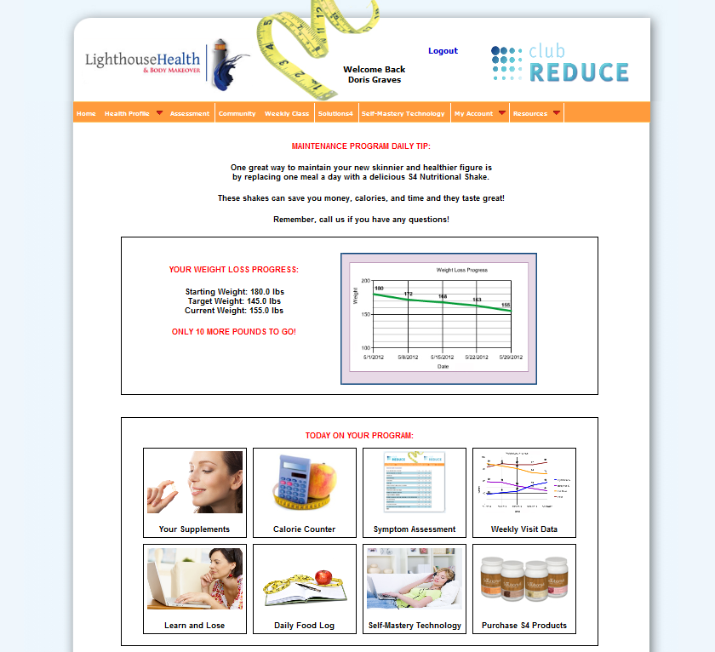
Calorie Counter
Individuals who keep food diaries are able to see just how many calories they are truly consuming a day. Habitual, emotional and mindless eating can contribute to consuming too many calories. Writing down everything you eat in a Food Journal makes you accountable and enables you to see unhealthy habits that need to be addressed to ensure your success.

Symptom Assessment
Each quarter (every 3 months) it will be important to give your body a checkup, by answering the Symptom Assessment. You can fill out your Symptom Assessment from the comfort of your own home on your Club Reduce Membership Site! The results will be sent to our clinic and you’ll be invited in for a free one-on-one-evaluation to make sure you’re still on the healthy path!

Sally Jones

Weekly Visit Data
In order to lose your weight, you need to surround yourself with positive, supportive people during this journey….That’s what we are here for! It helps to have someone to answer your questions about the food and about the program. You can see your progress here!

We at Club Reduce have been on these programs, so we know just how to help you.

We’ll be here for you when you have a triumph or even in a weak moment.
Supplements
Take your recommended supplementation! If you can’t take all of the recommended supplements, the good news is that The Nutritional Shake already has a lot of daily supplements that you need in it.

Learn and Lose Classes
Knowledge is POWER! The more you learn about why your should lead a healthy lifestyle, the more committed you will be! Each week you’ll receive a brand new Learn & Lose class, along with a homework assignment, and a free SMT session! Our goal is to help you be so savvy that you’ll never gain weight again! All of your Learn & Lose Classes will be available right at your fingertips on your Club Reduce Membership Site!

Order Solutions4 Product
Help curb your appetite and keep up your energy and your new look with supplements like Appetite Appeaser, Digestive Enzyme Blend, and Cellulite Cleanse. We are more than happy to create a recommended list of daily supplements based on the results of your Symptom Assessment. Remember, all of your favorite Solutions4 products are available at a 10% discount on your Club Reduce Membership Site!

Daily Food Log
Studies from the Mayo Clinic showed that patients who kept a food diary lost twice as much weight as those who didn’t

Self-Mastery Technology (SMT) can help you radically change the way you see yourself. Once you have this new and improved self- image, everything else changes… junk food and fast food lose their appeal, you only eat when you’re hungry – and so much more!

