Setting Up Your Club Reduce Membership
You might have already created a membership account if we sent you the invitation to fill out your assessment online prior to your initial evaluation appointment. If so, you can skip this section.
Your program coordinator should create a username and password with you and get you logged in for the first time during your first visit. If this was completed, you can skip this section.
If the program coordinator did not create your username and password during your meeting, you will need to follow these steps:
- Ask the clinic to send you an "invitation" email to the member website.
- Open the email, which should be titled "You're Invited to Club Reduce".
- Click the word "here" in the sentence:
"All you have to do is click here and follow the instructions."
- Type the code into the box, then click "Enter".
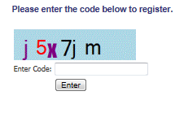

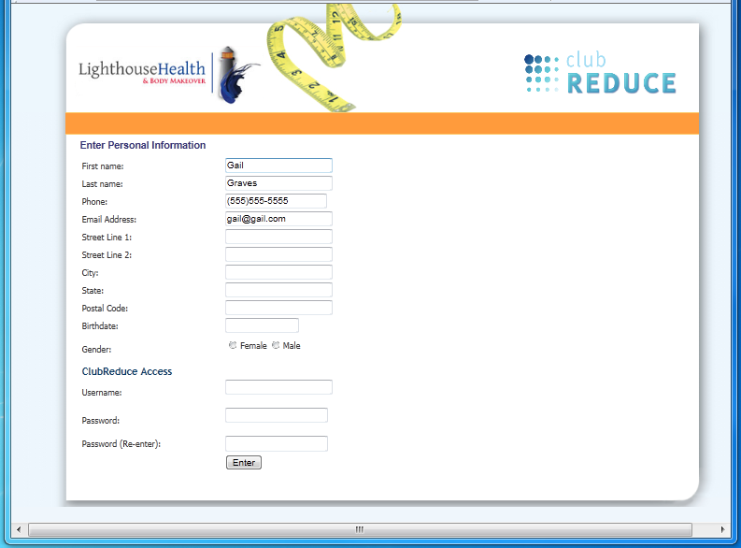
- You will see a screen where you can enter some personal information. Your information is always secure and we never sell or share any patient data to any other entity. By giving us your address, we can mail occasional promotional offers to you as well as appointment reminders. We ask for your gender and birth date because we need those items to correctly evaluate your symptom assessment.
At the bottom, choose your own username and password, enter them into the fields on your screen, and then click "Enter". Record them here:

Username: _______________________________

Password: ________________________________
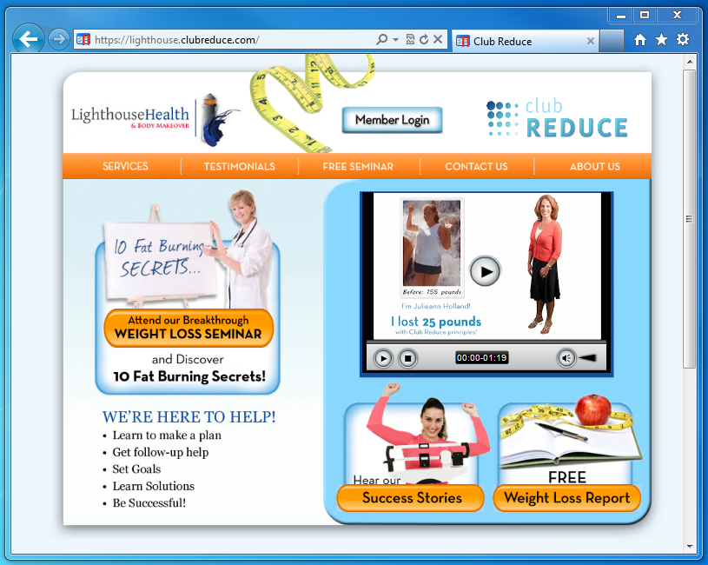
It is important to keep track of your username and password. If you forget them, you must call the clinic and have them reset for you.

6 - You will immediately be taken to the login screen which will have your username already entered. Enter your password and click "Log In".
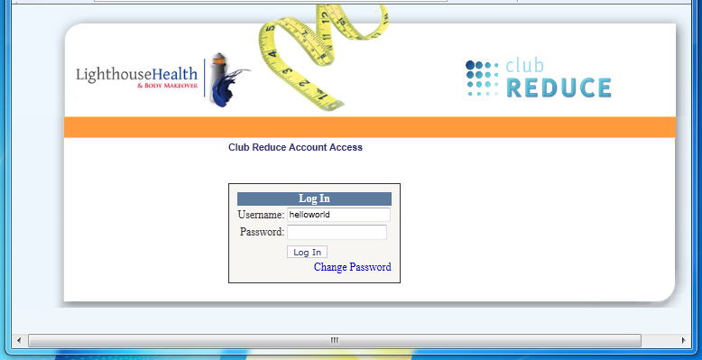

Logging into Your Club Reduce Membership Website

If you are not already logged in:
1- Go to: http://lighthouse.clubreduce.com
2- Click on "Member Login"
3- Enter your username and password then click "Log In"

4
3
2
Using Your Club Reduce Membership Website
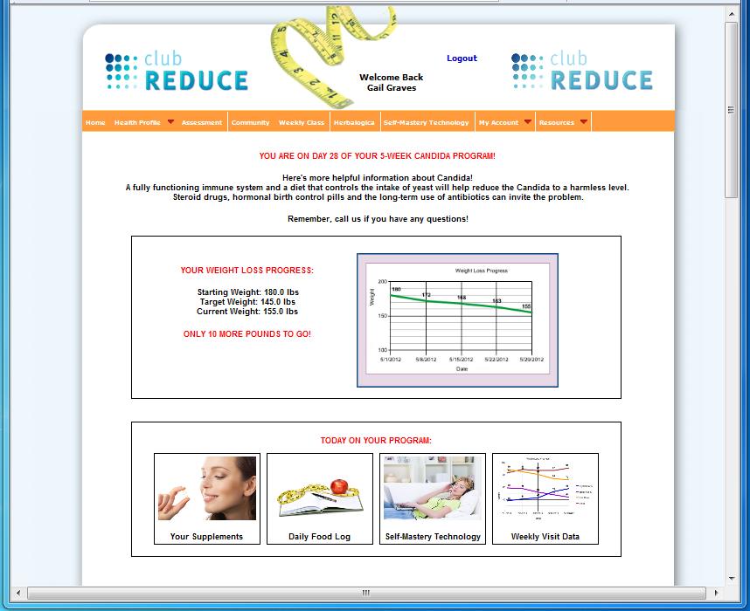
Once you have logged into your Club Reduce membership site you will see a screen that immediately updates you on what you need to know TODAY for your program. This page also includes a graph showing your weight loss progress, and your target goal weight.
Along the bottom of the screen you can:
- Read about the supplements you are taking
- Print a daily food log to track your meals
- Listen to the Self-Mastery audio session
- View the weekly visit data being recorded by your clinic
The orange menu bar across the top of the screen provides many features you can take time exploring . Make note of the assessment link which allows you to take the symptom assessment from home when your program coordinator tells you it is time.
The Self-Mastery Technology link will take you to another page where you can purchase your own SMT ZenFrames products to have the full SMT experience at home if you wish.

Using Your Club Reduce Membership Website
Ordering Product from your Membership Website
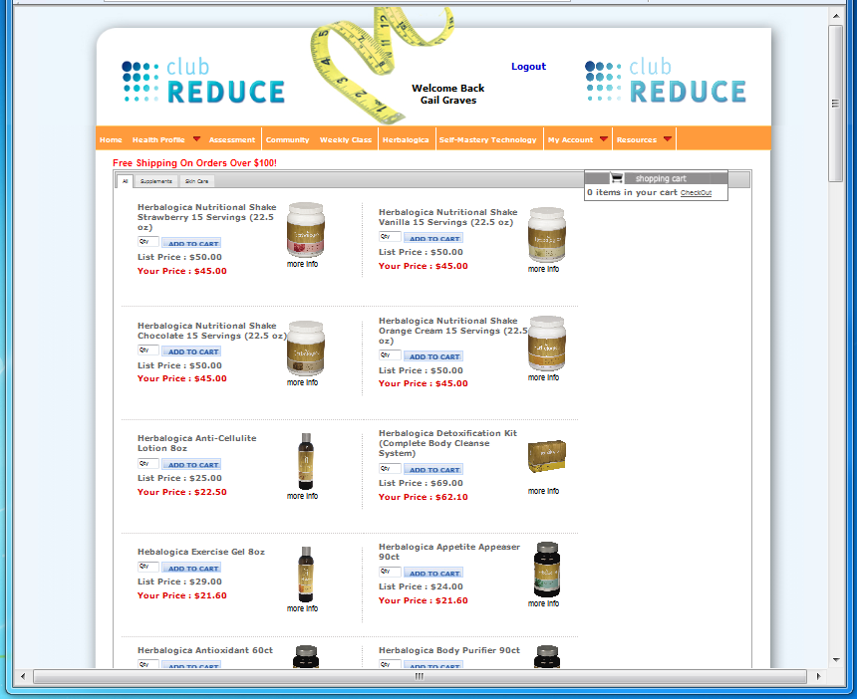
The Herbalogica link will open a page where you can order Herbalogica products and have them shipped right to your home. You even receive a 10% discount by ordering through your membership website; and all orders over $100 receive FREE shipping!

Take time to explore the "Resources" link which includes tools like exercise videos, recipes, and a calorie counter:
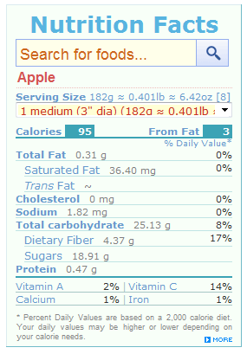

5
6
1

Quick Start Guide to
Your Club Reduce Membership

Congratulations on making the decision to change your life!
You are now a "member" of Club Reduce and have access to all the tools you will need to succeed.
One of these tools is the Club Reduce membership website where you can get daily information about your program
- Learn about the supplements you are taking
- Listen to SMT lessons
- Count your calories
- And enter daily weigh-in data
In addition, you will be able to monitor all the weight loss data being recorded during your weekly visits with your program coordinator. Each week when you visit our clinic, we will track your weight, BMI, hydration percentage, calories you are burning, and other items. When you go home, you can log into your Club Reduce membership site to see your progress from week to week!
The site also contains many other tools such as:
- Daily food log
- Community forum
- Exercise videos
- Recipes

And when it is time to re-take your Symptom Assessment, you can do it from home using your Club Reduce website! During maintenance you can even order Herbalogica products and have them delivered right to your door!

