
THE 12-WEEK CANDIDA WEIGHT LOSS PROGRAM
PROGRAM BREAKDOWN

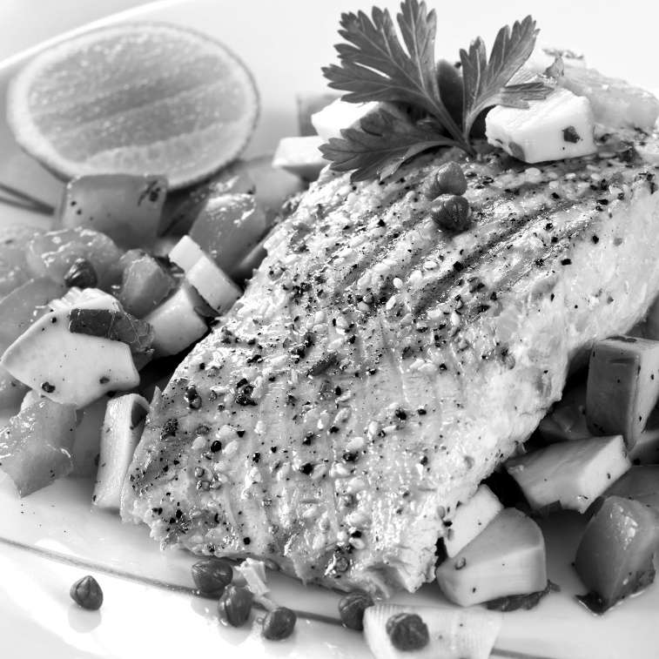

 | Products and Services Received | Price
1 | 12-Week Candida Kit | $1,014.00
12 | Weekly Evaluations to review progress | $720.00
12 | Sessions of Exercise with Oxygen Therapy | $600.00
12 | Sauna Treatments for detoxification | $600.00
12 | Body Wraps for inch loss and detoxification | $1,500.00
12 | Self-Mastery Technology (SMT) | $600.00
12 | Sessions of Whole Body Vibration | $600.00
1 | Follow Up Evaluation with Club Reduce Symptom Assessment | $50.00
 | 24 Hours a Day Phone Access to Club Reduce Staff | Priceless!
 | Total Price for Everything | $5,684.00
 | You Pay

