
THE 5-WEEK CANDIDA WEIGHT LOSS PROGRAM
PROGRAM BREAKDOWN

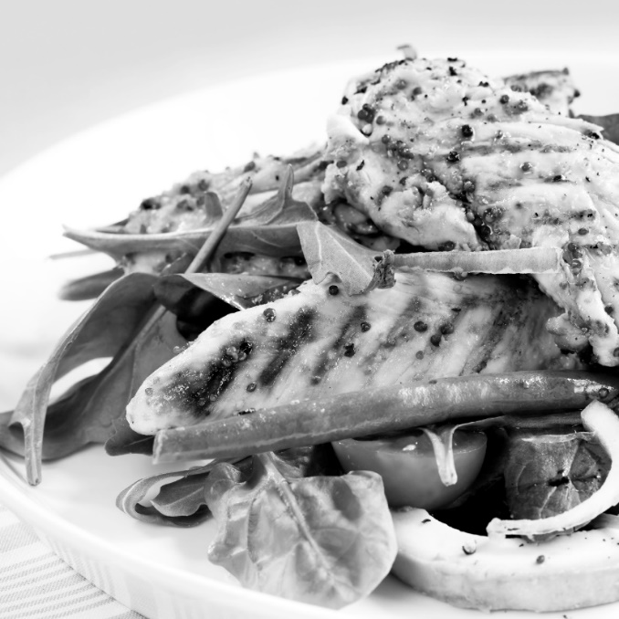

 | Products and Services Received | Price
1 | 5-Week Candida Kit | $661.00
5 | Weekly Evaluations to review progress | $300.00
5 | Sessions of Exercise with Oxygen Therapy | $250.00
5 | Sauna Treatments for detoxification | $250.00
5 | Body Wraps for inch loss and detoxification | $625.00
5 | Self-Mastery Technology (SMT) | $250.00
5 | Sessions of Whole Body Vibration | $250.00
1 | Follow Up Evaluation with Club Reduce Symptom Assessment | $50.00
 | 24 Hours a Day Phone Access to Club Reduce Staff | Priceless!
 | Total Price for Everything | $2,636.00
 | You Pay

