
NEUROPATHY BREAKTHROUGH PROGRAM
PROGRAM BREAKDOWN

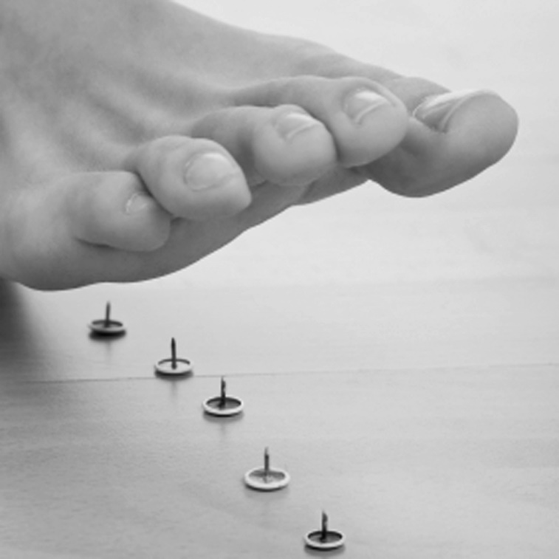

 | Products and Services Received | Price Per Session | Total
1 | Supplement Kit | $838.00 | $838.00
 | NeuroCare™ Sessions for pain relief | $50.00
 | Leg Wraps for leg detoxification and circulation | $50.00
 | Light Therapy for pain relief | $50.00
 | Self-Mastery Technology Development tool | $50.00
 | Whole Body Vibration | $50.00
 | Follow up Evaluation at the completion of this program | $50.00
 | Total Price for Everything
 | You Pay

